My experience of Taizé, July 2012
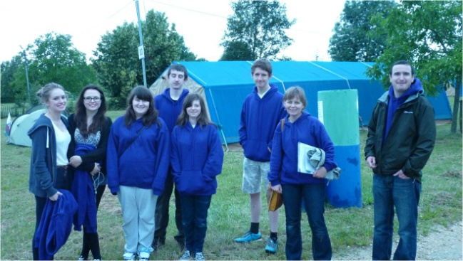
In July this year a group of year 10 and 11 students (aged 15 or 16) from Ysgol Dinas Bran and from St Joseph’s Catholic and Anglican High School in Wrexham had the opportunity to visit the Taizé Community in the Burgundy region of France.
We were unsure of what to expect, and a little scared about what we would be facing especially since to do something as adventurous as camping meant that we were completely dependent upon the weather. Our tents were well tested with several thunder storms, but we all stayed (reasonably) dry.
Throughout the week we engaged in many discussions and it was such a diverse experience meeting people from all over the world. We quickly fell into the very well ordered Taizé programme which involved us in going to church three times a day. However daunting this may sound, we all learned how prayer can be more than just a chore, because the opportunities for reflection the community provide are so beautiful and refreshing. As a young person in the UK church can sometimes feel like something you are morally obliged to do or engage with. I’ve often felt forced into a way of praying in church which doesn’t feel natural to me. During this week in Taizé however, I felt completely at ease with religion, and felt that I could just be myself, I felt free to pray or not to pray, and that freedom somehow made it easy.
Each morning we had a Bible introduction from Brother Jasper, who managed to talk about the Bible texts and to keep his difficult teenage audience engaged. We also had to do some practical work; our group had to clean the toilets twice during the week. Horrid as this may sound we had a brilliant time doing this; we found ourselves giving a rendition of favourite musical numbers with an array of languages. In our group there was a multi-lingual extravaganza with people from France and Germany singing along with our group from Wales.
It wasn’t all work in Taizé: Tim Feak took his guitar and we spent time relaxing by our tent, playing frisbee and football and getting to know other people who had come to this beautiful location. There’s a ‘not for profit’ cafe at Taizé where people would socialise and we spent a lot of time there eating ice-cream and crepes.
My experience at Taizé has been completely unique, I thoroughly enjoyed my time there and our whole group came away from there, keen to go back for another visit.
Joanna Stallard (15)

